My Experience with Image Segmentation for Interior Design:
This Diwali, I wanted to repaint my house, but I found myself in a fix. What colours or shades would actually look good on my walls? I didn’t want to spend money on paint and then regret the choice. I looked around for some apps or tools that could help me visualise it, but nothing really matched what I had in mind. So, being a programmer, I thought: why not build a quick proof-of-concept myself?
That’s how I ended up experimenting with image segmentation for interior design. The idea was simple: take a photo of my room, break it down into parts (like walls, floor, furniture), and then play around with colours, patterns, or textures on each part, virtually, without lifting a brush. Here’s what I did and what I learned in the process.

What is Image Segmentation?
Image segmentation is basically splitting an image into different parts, where each part represents a meaningful object or area. For example, in a living room photo, segmentation can help us separate the sofa, the wall, the floor, and so on.This is super useful for interior design because you can change the color of the wall or try different tiles on the floor without actually painting or renovating anything.

How Does Image Segmentation Work?
Here’s the basic process I followed:
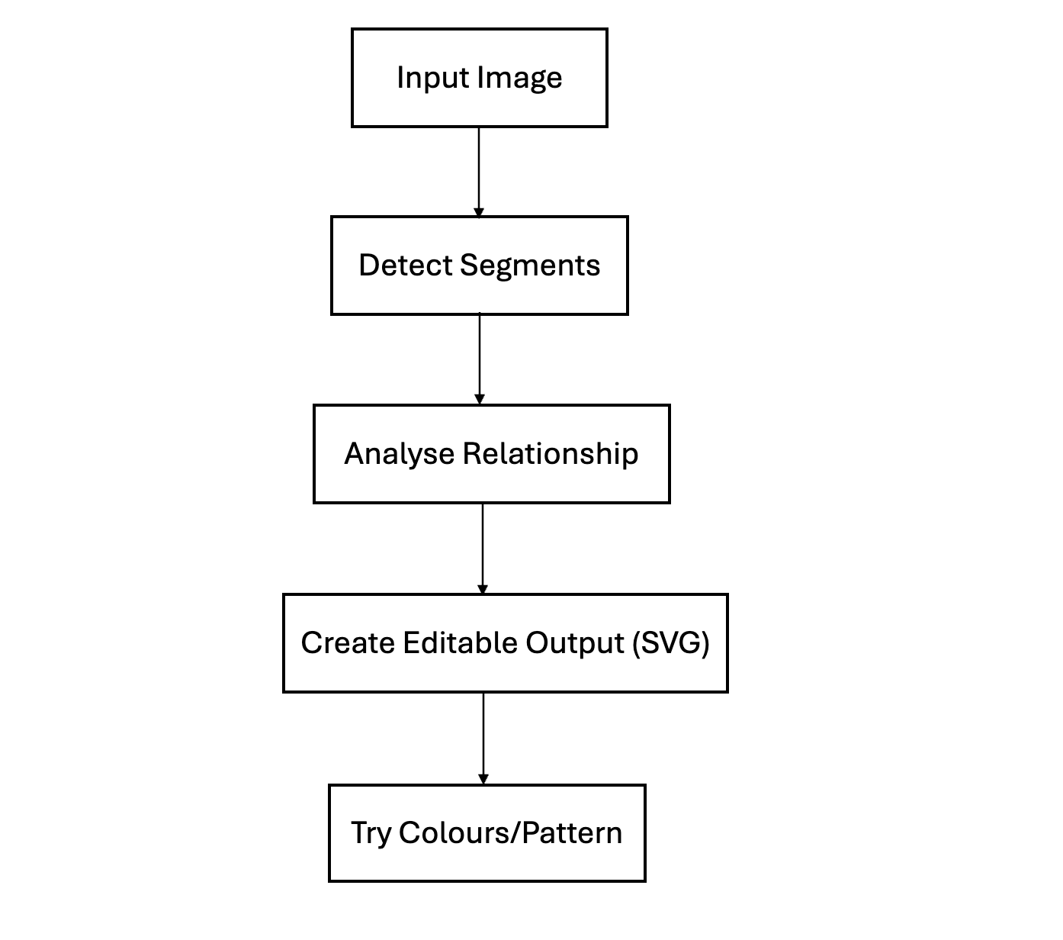
- Input Image: Start with a photo of a room.
- Detect Segments: Use a model (FastSAM) to find the outlines of different objects or areas.
- Analyze Relationships: Figure out if some segments are inside others (like a painting on a wall).
- Create Editable Output: Convert the segments into something we can edit easily, like SVG.
- Try Colors/Patterns: Now we can recolor or add patterns to each part.

What Surprised Me
- Models are Powerful, but Not Magic: Pre-trained models like FastSAM can do a lot, but sometimes they miss small objects or merge things you want separate.
- Polygons are Tricky: Figuring out if one shape is inside another (like a switch on a wall) is not as easy as it sounds. I had to use some geometry and OpenCV functions to get it right.
- SVG is Super Handy: Once you have the segments, SVG makes it easy to change colors or add patterns.

A Simple Example
Let’s say you have a wall with a painting and a switch. The model gives you three shapes: wall, painting, and switch. You need to know that the painting and switch are “inside” the wall, so when you recolor the wall, you don’t accidentally cover them.

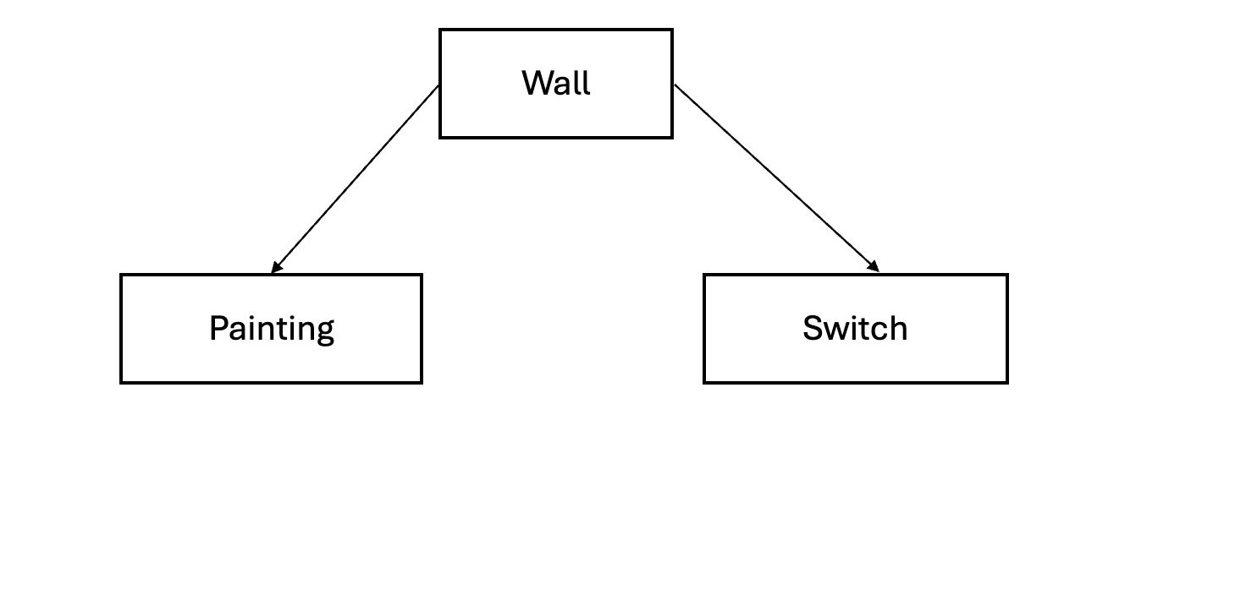Example Screenshots:
Below are some screenshots to show how the room looks before and after adding different tile patterns.

- Original Room (No Tile Pattern):
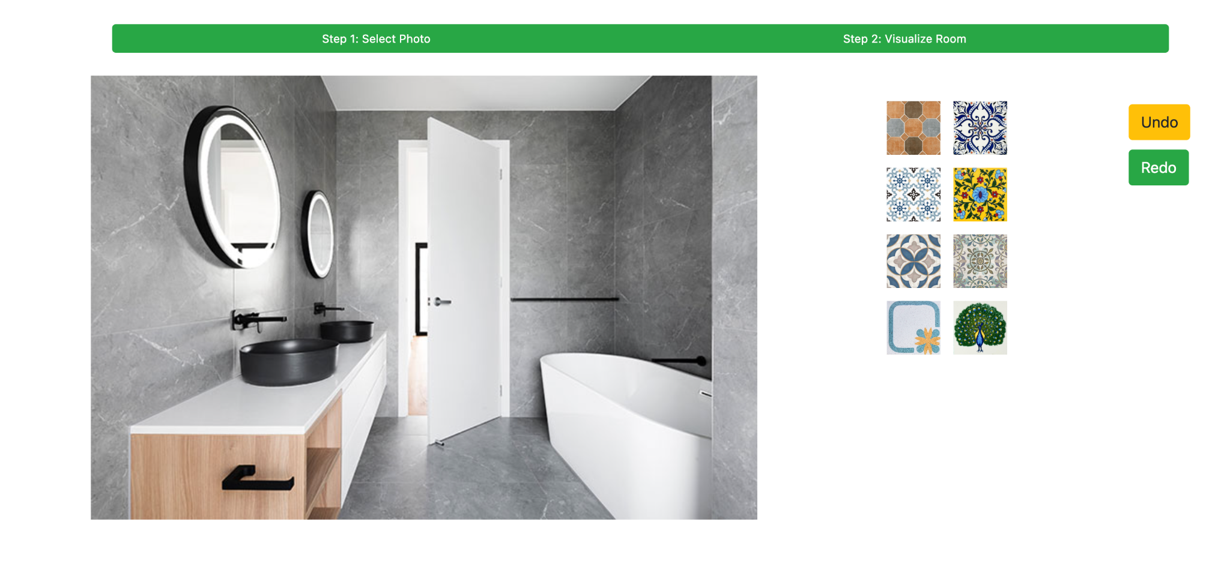
- Room with Different Tile Patterns on Wall and Floor:

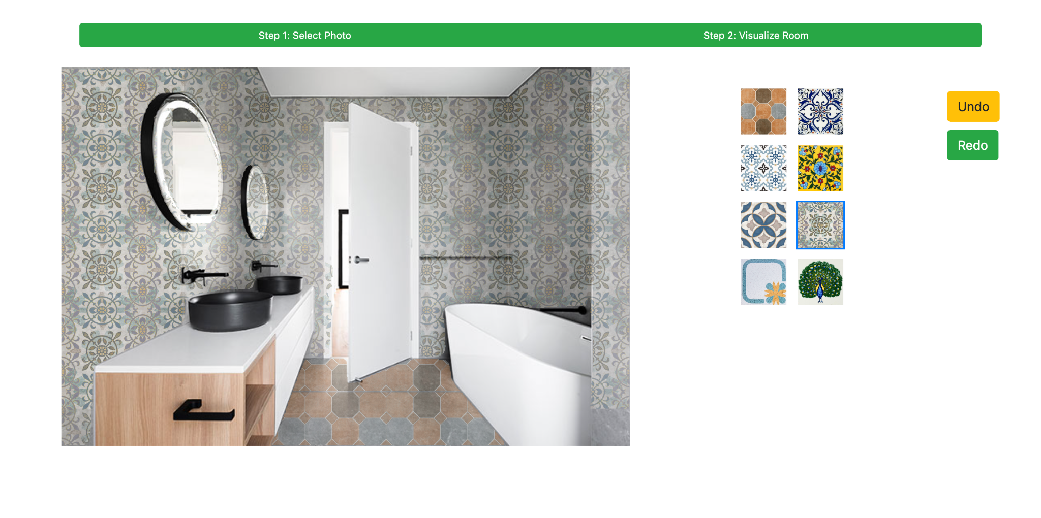

What I Learned
- Start Simple: Don’t try to segment everything perfectly at first. Even rough segments are useful.
- Check Your Outputs: Sometimes the model makes mistakes. Visualizing the segments helps catch these early.
- Automate What You Can: Saving and reusing results saves a lot of time, especially if you’re working with big images.
- Have Fun: It’s really satisfying to see a room change colors with just a few clicks.

Final Thoughts
This little project taught me a lot and made my Diwali repainting decision so much easier. Image segmentation opens up a lot of creative possibilities, not just for interior designers but also for paint shop owners, customers who want to preview colours before buying, or even small contractors who want to show clients a quick visual before starting work.
The best part is, you don’t need to be a computer vision expert to try this out. Just experiment, learn along the way, and enjoy the process. Who knows, you might end up redesigning your own room virtually, and save yourself a lot of time and money in the real world.

